NAME: BILAL ABID ABBASI
CLASS: 1 SEMESTER
ICT LAB

PROJECT REPORT

PROJECT REPORT

This project report provides a comprehensive technical and functional analysis of the Shoe Sample Hub, a web development project designed to showcase footwear samples and provide a directory for major shoe brands.
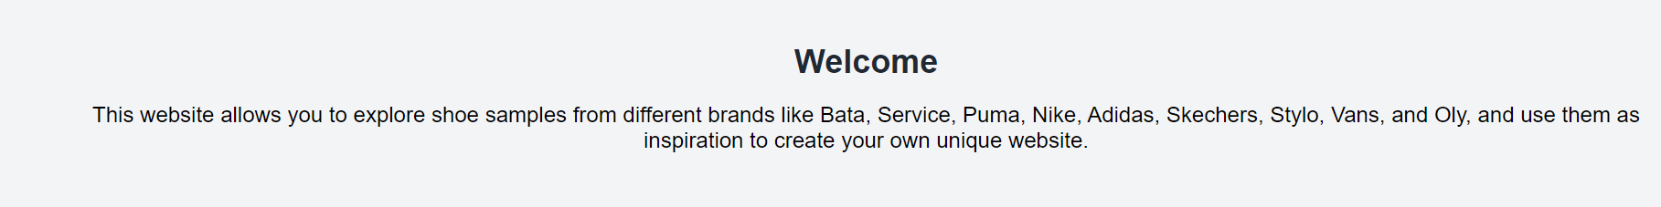


PROJECT REPORT: SHOE SAMPLE HUB

Developer: Bilal ABID Abbasi

Project Date: 2026

Subject: ICT Lab Project

Technology Stack: HTML5, CSS3, Web Hyperlinking

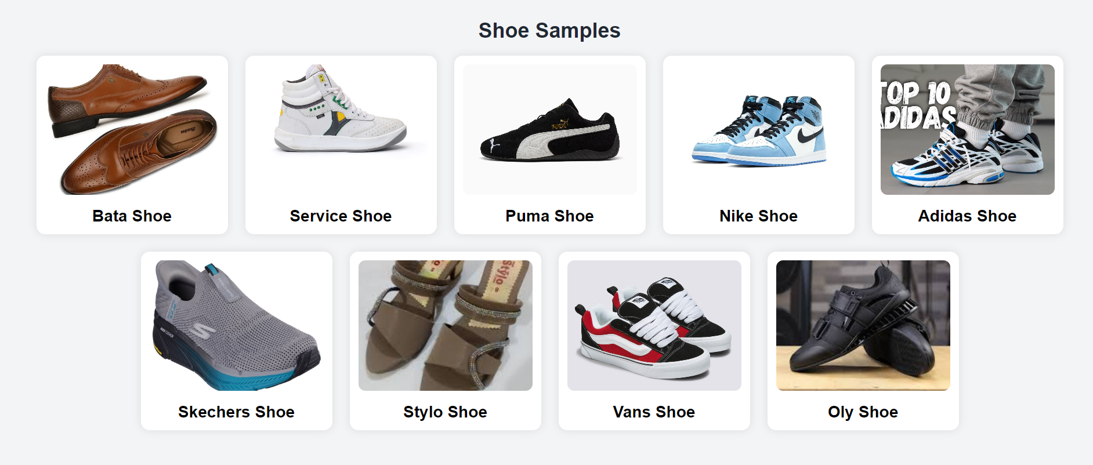

1. Project Overview & Objectives
The Shoe Sample Hub is an interactive web portal developed to simplify the discovery of footwear styles from globally and locally recognized brands. The primary objectives of this project include:
- Centralized Resource: Creating a single platform where users can find direct links to major shoe retailers.
- Visual Inspiration: Providing a gallery of diverse shoe samples to help users build their own unique fashion sense.
- Technical Proficiency: Demonstrating the use of semantic HTML, internal navigation, and external linking strategies.

2. Technical Architecture
The project is built using a clean, section-based architecture that prioritizes readability and user experience.

2.1 Front-End Structure
- HTML5 Semantic Tags: The code utilizes <header>, <nav>, <section>, and <footer> tags to define the document's structure, which improves SEO and accessibility.
- CSS Integration: The project links to an external file, project.css, ensuring that style and content remain separate for better maintainability.
- Character Encoding: The document uses UTF-8 encoding to ensure all text characters are displayed correctly across different browsers.

2.2 Navigation Logic
The navigation system is built using internal anchors. By assigning unique id attributes to each section the navigation links allow users to jump directly to specific content without refreshing the page.

3. Detailed Component Breakdown

3.1 The Header & Navigation Bar
The header serves as the "Hero" section, introducing the brand identity with the title "Shoe Sample Hub". The navigation bar provides four distinct entry points: Home, Brands, Gallery, and Contact.

3.2 The Brands Directory
This section is unique because it features a dual implementation of the brand list. The secondary implementation is highly functional, utilizing target="_blank" for all hyperlinks.
- Local Brands: Service (servis.pk), Bata (bata.com.pk), and Stylo (stylo.pk).
- Global Brands: Nike, Adidas, Puma, Sketchers’, and Vans.
- Interactive Design: Each brand is encapsulated in a brand-card div, allowing for hover effects and distinct styling in CSS.

3.3 The Visual Gallery
The gallery is the core visual component, featuring nine distinct "shoe cards". Each card consists of an image and a descriptive heading.
- Modern Formats: The project demonstrates compatibility with various image formats, including , .avif, and .jfif.
- Accessibility: Every image includes an alt tag (e.g., alt="Nike Shoe"), ensuring the site is accessible to visually impaired users using screen readers.

4. Visual Representation
Below is a simulated screenshot of the project's layout, showing the relationship between the navigation bar, the brand links, and the image gallery.
{"action": "image_generation", "action_input": "{'prompt': 'A high-resolution screenshot of a website titled Shoe Sample Hub. It features a clean white and light blue color scheme. At the top is a navigation bar with Home, Brands, and Gallery links. Below that, a grid of stylish shoe photos (sneakers and formal shoes) is displayed with brand labels like Nike, Adidas, and Bata. The footer at the bottom says Created by Bilal abid abbasi. The layout is professional and minimalist.

5. Contact & Institutional Details

The contact section provides direct communication channels for the hub:
- Email Support: shoesamplehub@gmail.com.
- Phone Contact: +92 3710181459.
- Branding: The footer establishes ownership with a copyright notice for the year 2026.


6. Conclusion
The Shoe Sample Hub successfully integrates foundational web development techniques with a clear marketing purpose. By utilizing modern HTML5 standards and responsive navigation, it provides a seamless user experience that is both functional and informative.

